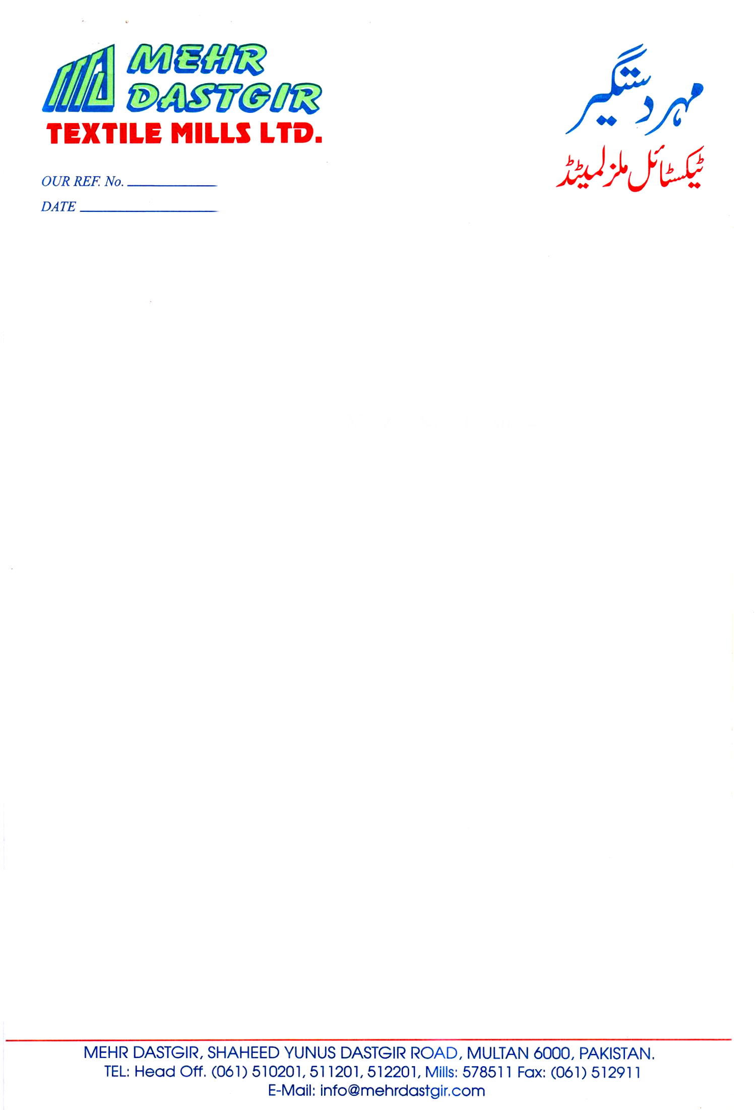

**<To2>**

**TO WHOM IT MAY CONERN**

This is to certify that <Name> S/O <fname> Card No. S-305 resident of Chah Bhatti Wala P.O. Basti Bohar, Mauza Dehr Tehsil & District Multan had been working with us as <Designation> from <From2> to <To2>. He had been hardworking and dutiful. We wish him happy and prosperious future.

This certificate is issued on his request.

For Mehr Dastgir Textile Mills Limited.

**(Anjum Iqbal Malik)**

**Mills Manager**